Portfolio

**Binary.com**

**Website**: webtrader.binary.com

**Description:** The project’s objective was to develop a single page web app for traders.

The design was minimalistic but feature rich, I was the team lead and managed two other telecommuters. I used Webpack for development workflow, AMD modules to deliver different parts of the app on demand, SASS for styling and Rivets-JS for two-way data-binding.

Backend communication was via WebSocket, I used local storage for persistent sessions. Integration tests where in Nightwatch.

**Technologies used:** Webpack, Es6, AMD Modules, Sass, WebSocket, Travis.

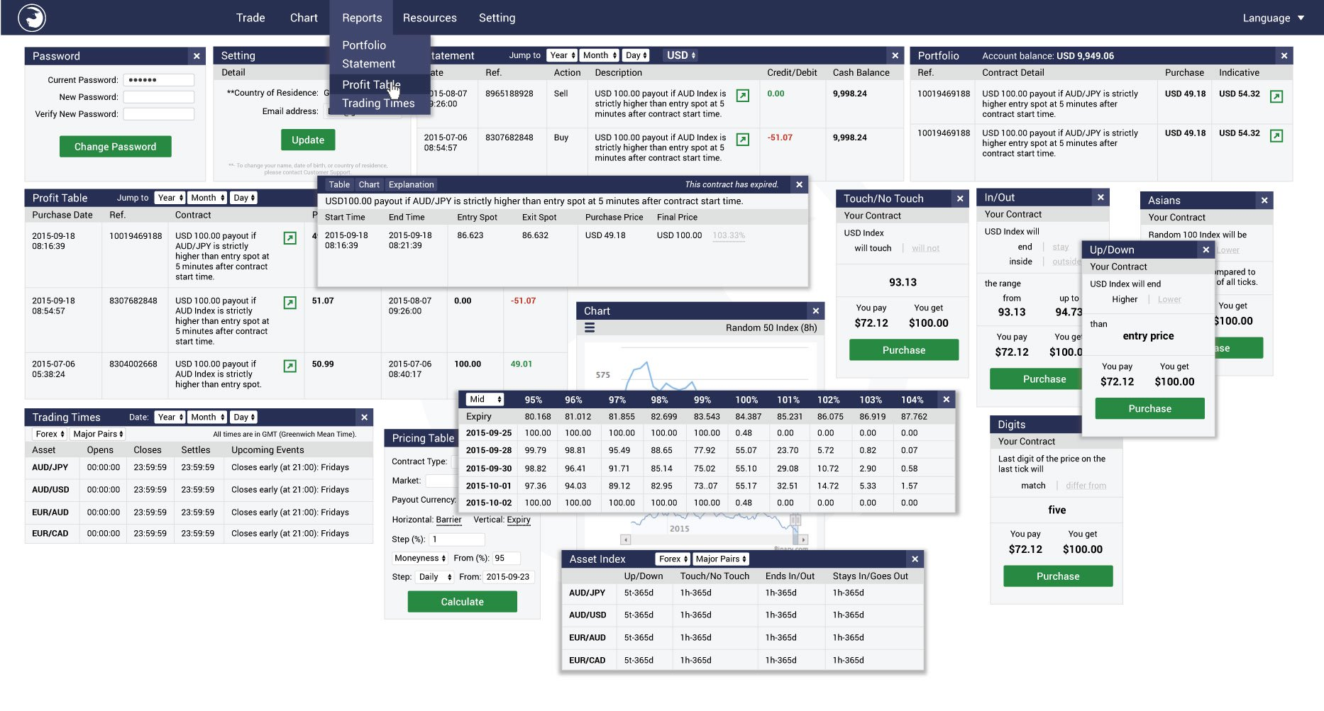

**Website**: charts.binary.com

**Description:** A complete charting library for traders, Features like indicators, overlays and draw tools.

I started the project from scratch and delivered the first few major versions, it’s now maintained by a colleague. I used ReactJS and MobxJS for state management, SASS for styling, Webpack and Babel for transpiration,

And Jest for unit testing. This project is both available as a NodeJS library and a standalone web app.

**Technologies used:** ReactJS, MobxJS, Webpack, SASS, Jest.

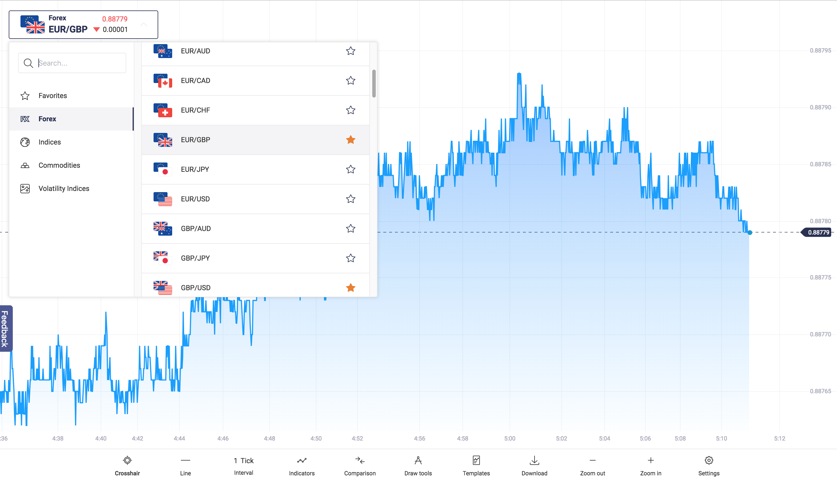

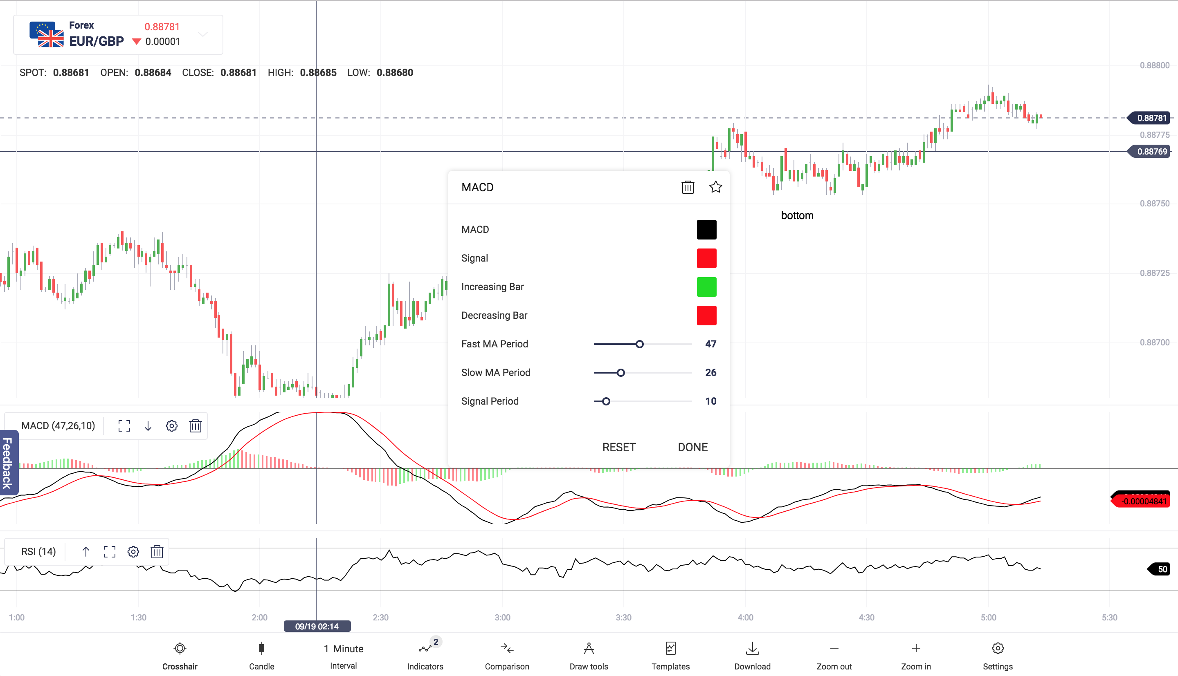

**DominateRFID**

**Website:** dominaterfid.com



**Description:** A simple website explaining what the company is offering, It was an existing project, I used jQuery with some plugins to extend it behind just a few pages, to a complete website, refactored the styles, menus, scrolling and added a few animated svgs. I also extended the python Django server side to send alerts and keep statistics.

**Technologies used:** jQuery, Django, Restful services.